

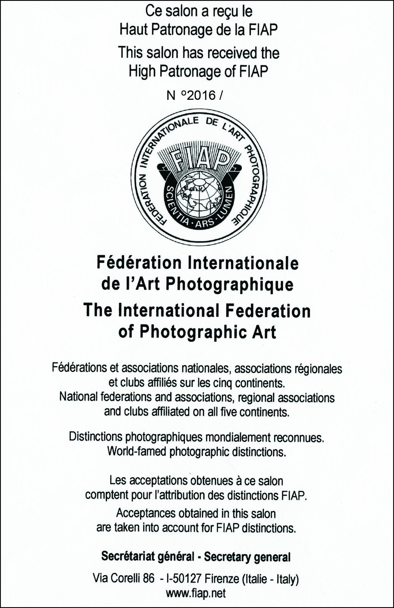
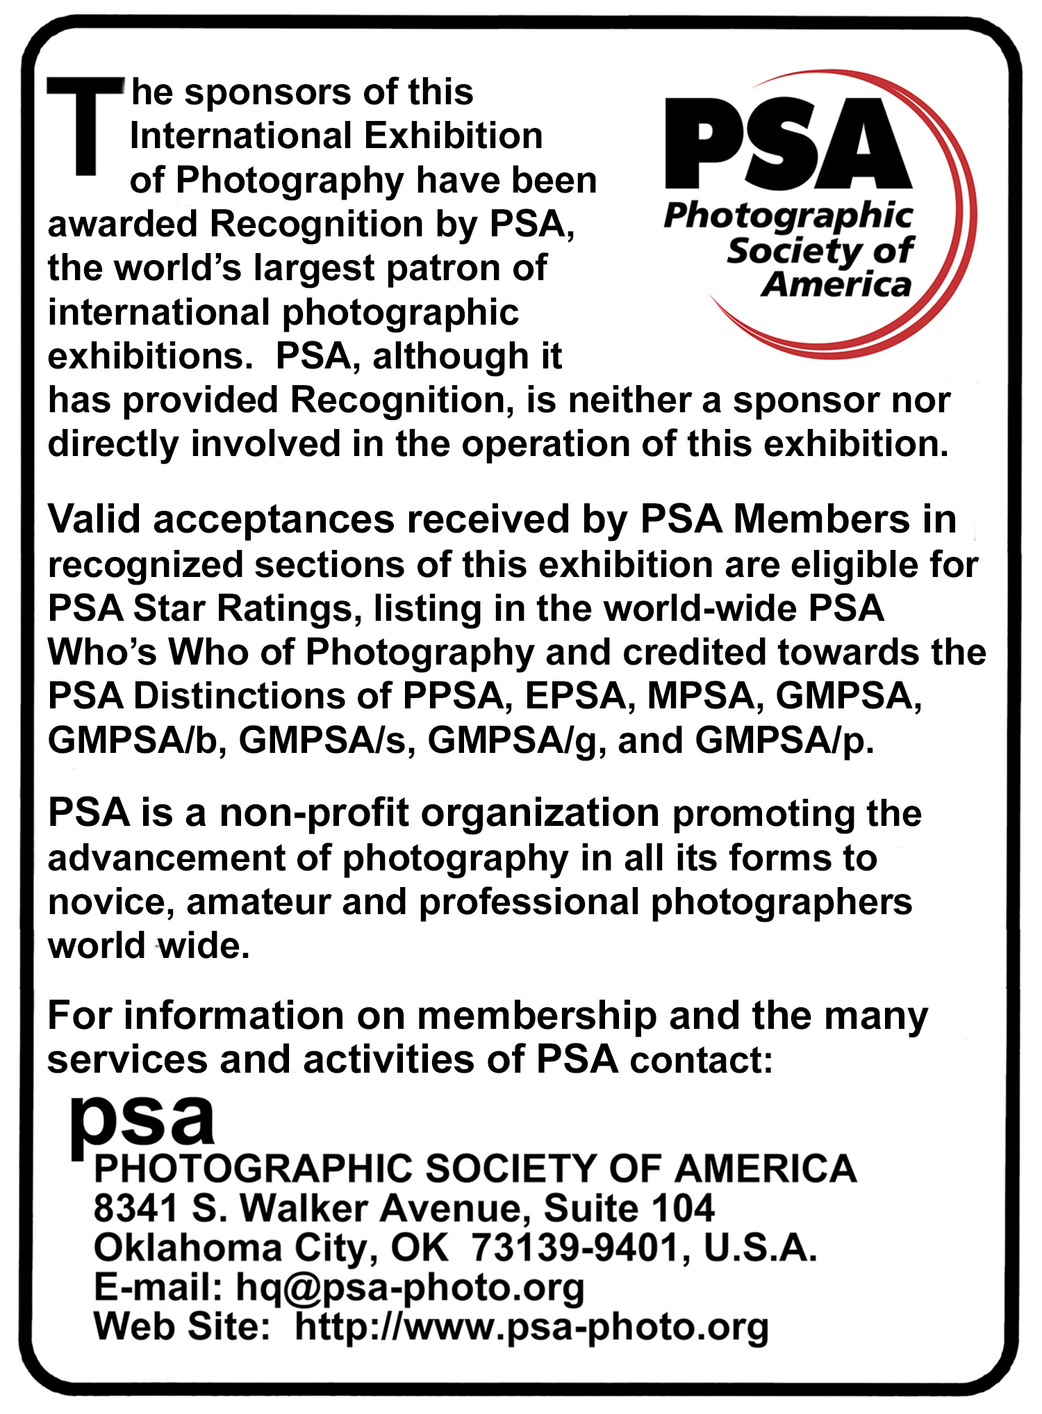

CIRCUIT PHOTO CONTEST ”ECOLOGICAL TRUTH 2019”
1.ORGANIZER:
Culture Center Zajecar , Photo Club 202, Zajecar, Serbia
14th EXHIBITION OF PHOTOGRAPHY "ECOLOGICAL TRUTH 2019 - ZAJECAR"
Foto klub "Nova Gorica," Nova Gorica, Slovenia
7th EXHIBITION OF PHOTOGRAPHY "ECOLOGICAL TRUTH 2019 – NOVA GORICA"
Academy of photography Bulgaria "YANKA KYURKCHIEVA", Sofia, Bulgaria
7th EXHIBITION OF PHOTOGRAPHY "ECOLOGICAL TRUTH 2019 - SOFIA"
2. PARTICIPATION
The exhibition is open to anyone; however, an entry may be rejected when the sponsoring organization or its agent, in its reasonable discretion, believes the entry does not conform to the exhibition rules and conditions.
An entrant’s images will not be presented to the judges consecutively. An entrant’s four images will be distributed throughout four rounds of judging in that section. Distribution of images shall be in the same round order as submitted by the entrant.
Entries must originate as photographs (image-captures of objects via light sensitivity) made by the entrant on photographic emulsion or acquired digitally. By virtue of submitting an entry, the entrant certifies the work as his own (aliases are not permitted). The entrant permits the sponsors to reproduce all or part of the entered material free of charge for publication and/or display in media related to the exhibition. This may include low resolution posting on a website. Note: Entrants who indicate that their images may not be reproduced or used “will not be eligible for awards” or inclusion in audio-visuals of the exhibition “and could be subject to disqualification” by the exhibition sponsors.
The exhibition assumes no liability of any misuse of copyright. Images may be altered, either electronically or otherwise, by the maker. All parts of the image must have been photographed by the author who is holding the copyright of all works submitted.All final work must be on photographic film, or on electronic file, or on photographic or electronic print material, mounting excepted.
No title or identification of the maker shall be visible anywhere on the face of an image, print mat or mount entered in a PSA Recognized exhibition.
Each image must have a unique title. Once an image has been accepted in a PSA Recognized exhibition, that same image, or a like “in camera” or a “reproduction” duplicate of that image:
i. May not be entered or re-entered in any section of the same Division Star Ratings class in that exhibition regardless of media, format, or title.
ii. May not be re-titled for entry in any other PSA Recognized exhibition, including translation into another language.
iii. Images meeting the Monochrome Definition and non-manipulated color images from the same capture shall be considered the same image and must be given the same title.
Words such as “Untitled” and “No Title” are not acceptable as part or all of an image’s title, nor are camera capture filenames.
An image may be entered in only one section where acceptances of that image in multiple sections would be eligible for the same star path.

If at any time, it is determined in the reasonable discretion of the exhibition organizer or the judges before, during, or after the judging of an exhibition that an entrant has submitted entries where one or more images may fail to comply with these Conditions of Entry, including the stated definitions, the exhibition organizers reserve the right to delete the entry from the exhibition and void any or all acceptances or awards in connection with the exhibition. Fees may be forfeited or refunded in these circumstances. The entrant acknowledges that the decision of the exhibition organizers or the judges is final.
In order to ensure that images comply with the Conditions of Entry and definitions, the exhibition organizers may carry out reasonable measures to verify that:
a) the images are the original work of the entrant and
b) the images comply with the rules and definitions as set out in these Conditions of Entry.
These steps include, but are not limited to, questioning any entrant, requiring the submission of RAW files or other digital files representing the original capture of the submitted image(s), confronting the entrant with evidence that one or more submitted images fails to comply with the Conditions of Entry (also known as Entry Rules), and offering the entrant a reasonable opportunity to provide counter evidence to refute the exhibition organizer’s evidence by a set deadline. Such entries that are not cleared or are still questionable after the entrant has presented evidence may be considered in breach of these Conditions of Entry, and declined. Such entries may be referred to PSA for further investigation of possible ethics violations.
PSA retains the right to investigate in any way all complaints/suspicions of breaches of entry conditions, impose sanctions if deemed necessary, void the acceptances of any image found to violate the PSA rules, include the entrant’s name on the list of sanctions provided to Exhibitions, and share such investigations with FIAP. Entrants automatically agree to these terms by the act of entering the Exhibition and agree to cooperate with any investigation.
DATA PROTECTION:
By entering this exhibition, you are explicitly consenting to the personal details you have supplied, including email addresses, being held, processed and used by the exhibition organizers for purposes associated with this exhibition. You also explicitly consent to such information being sent to organizations that have accorded official recognition, patronage or accreditation to this exhibition. You acknowledge and accept that entering this exhibition means that the status and results of your entry may be made public.
NOTICE: When an entrant goes into to the Entry Form to submit an entry the entrant will see a feature to affirm he or she has read these Conditions of Entry when he or she fills out the entry form. If the entrant does not so affirm the entry will not be submitted.
All entries shall conform to the stricter of these definitions for acceptances to be validated by all the International Organizations granting recognition or patronage.
3. SELECTION AND THEMES
A) EARTH SUFFERS - (color or monochrome) Photojournalism PSA division Recognition
Human activities are detrimental to nature, the impact of man on the destruction of nature. Photographs on the exhibition should show the viewers how people negatively affect the planet earth, and that man's work is destroying our nature.
B) LANDSCAPE - (color or monochrome) Travel PSA division Recognition
C) NATURE - (color or monochrome) NATURE PSA Recognition
D) FREE - (monochrome) PID PSA monochrome Recognition
E) FREE - (color) PID PSA color Recognition
4. NUMBER OF WORKS
In order to participate in the “ECOLOGICAL TRUTH 2019”, the authors apply with monochrome and color photos. Maximum number of works is four (4) images per section, the maximum dimensions 1920 pixels horizontal x 1028 vertical, 300 dpi JPG compressions 7-10. The maximum total size must not exceed 2 megabytes. An entrant’s four images will be distributed throughout four rounds of judging for that section. Samsung 5100 Class Full HD 40", 1920x1028 will be used to display the images to the judges. Each image must have a unique title. Once an image has been accepted in a PSA Recognized exhibition, that same image, or a like “in camera” or a “reproduction” duplicate of that image:
I. May not be re-entered in any section of the same Division Star Ratings class in that exhibition regardless of media, format, or title.
II. May not be re-titled for entry in any other PSA Recognized exhibition.
Words such as “Untitled” and “No Title” are not acceptable as part or all of an image’s title, nor are camera capture filenames or titles consisting of only numbers. No title or identification of the maker shall be visible anywhere on the face of an image, print mat or mount entered in a PSA Recognized exhibition. All entrants in must provide name and country data exactly the same in each exhibition entered to receive proper credit
Each author receives his/her own results-marks separately for each exhibition via his/her personal e-mail.
5. PARTICIPATION FEE:
Participation fee for 1 and 2 theme is 32 euros (44$).
Participation fee for all five theme is 40 euros (50$).

for CLUBS (10 or more by participants) is 32 euros (44$) per author.
The fee covers all 3 clubs and all 3 exhibitions. Participation fee is mandatory for all participants of the exhibition.
The fee can be paid via PayPal (the following cards are accepted: VISA, MASTER CARD, AMEX, JCB and DINERS). Dinar gyro account is 160-353153-51. All instructions can be viewed at the official website of the club www.photoclub202.com The works of the authors who do not pay the participation fee will not be taken into consideration. By participating in the competition, the author accepts the propositions and the rules of the organizer.
6. CATALOGUE
Photos are used only for creation of the Catalogue. The authors who have paid the participation fee and participate in this circular exhibition receive high-quality catalogue printed on paper. The format of the Catalogue is 240mm x 220mm, 146 pages, luxury prepared, rated with 5 stars by FIAP committee.
7. THE EXHIBITION CALENDER:
Receiving images | 01 May 2019
Judging | 13 May 2019 – 15 may 2019 – Photo club 202 club premises, Zajecar, Serbia
Judging | 13 May 2019 – 15 may 2019 – Photo club Nova Gorica club premises, Slovenia
Judging | 13 May 2019 – 15 may 2019 – Bulgarian Academy of photography premises, Sofia, Bulgaria
Selection results (at the website) | 25 May 2019, each author receives the results via his/her personal e-mail
Exhibition / Projection | 25 June 2019 – Gelery “Radul begov konak”, Zajecar, Ljube Nesica1, Serbia
Exhibition / Projection | 25 June 2019 – Photo club Nova Gorica club premises, Ul. Gradnikove brigade 49, Slovenia
Exhibition / Projection | 25 June 2019 – Galery, Sofia, Bulgaria,
Delivery of the Catalogue | 31 Juli 2019
The results can be seen at the website: www.photoclub202.com
8. SUBMISSION OF WORKS:
Upload at the website: www.photoclub202.com or send by e-mail to photoclub202@gmail.com , or send a CD to the following address:
Rasa Milojevic, FOTO CLUB 202, Trg Oslobodjenja bb, 19000 Zajecar, Serbia.
9. CONTACT:
Rasa Milojevic,EFIAP/g,EsFIAP,MFFSS
Salon Chairman
+381 64 822 86 03
e-mail: photoclub202@gmail.com

JURY, PRIZES AND PATRONAGE

10а. Culture Center Zajecar , Photo Club 202, Zajecar, Serbia
14th EXHIBITION OF PHOTOGRAPHY "ECOLOGICAL TRUTH 2019 - ZAJECAR"
10b. JURY:
Bojan Ivanov, photographer (Bulgaria)
Zoran Purger, MF FSS (Serbia)
Simon Kovacic, AFIAP, KM FZS (Slovenia)
Delegate FSS, Maja Stosic, (Serbia)
10c. AWARDS: FIAP best by badge
A) EARTH SUFFERS - (color or monochrome)
- PSA, FIAP, FSS, gold medal, - TWO praises FIAP, One FSS, BALKAN and PSA HM Ribbon - SALON gold, silver, bronze and 5 praises
B) LANDSCAPE - (color or monochrome
- PSA, FIAP, FSS, gold medal, - TWO praises FIAP, One FSS, BALKAN and PSA HM Ribbon - SALON gold, silver, bronze and 5 praises
C) NATURE – (color or monochrome)
- PSA, FIAP, gold medal, - TWO praises FIAP, One FSS, BALKAN and PSA HM Ribbon - SALON – gold, silver, bronze and 5 praises
D) FREE – monochrome
- PSA, FIAP, FSS, gold medal, - TWO praises FIAP, One FSS, BALKAN and PSA HM Ribbon - SALON – gold, silver, bronze and 5 praises
E) FREE - color
- PSA, FIAP, gold medal, - TWO praises FIAP, One FSS, BALKAN and PSA HM Ribbon - SALON – gold, silver, bronze and 5 praises

11а. Foto klub "Nova Gorica," Nova Gorica, Slovenia
7rd EXHIBITION OF PHOTOGRAPHY "ECOLOGICAL TRUTH 2019 – NOVA GORICA"
11b. JURY:
Mirko Bijuklic, EFIAP, MF FZS (Slovenia)
Dusan Miska, EFIAP, MF FZS (Slovenia)
Dragan Ilic, painter (Serbian)
11c. AWARDS: FIAP best by badge
A) EARTH SUFFERS - (color or monochrome)
- PSA, FIAP, FZS, gold medal, FZS silver and bronze medal - TWO praises FIAP, One praise FZS, BALKAN and PSA HM Ribbon - SALON gold, silver, bronze and 5 praises
B) LANDSCAPE - (color or monochrome
- PSA, FIAP, FZS, gold medal, FZS silver and bronze medal - TWO praises FIAP, One praise FZS, BALKAN and PSA HM Ribbon - SALON gold, silver, bronze and 5 praises
C) NATURE – (color or monochrome)
- PSA, FIAP, gold medal, - TWO praises FIAP, One praise FZS, BALKAN and PSA HM Ribbon - SALON – gold, silver, bronze and 5 praises
D) FREE – monochrome
- PSA, FIAP, FZS, gold medal, FZS silver and bronze medal - TWO praises FIAP, One praise FZS, BALKAN and PSA HM Ribbon - SALON – gold, silver, bronze and 5 praises
E) FREE - color
- PSA, FIAP, FZS, gold medal, FZS silver and bronze medal - TWO praises FIAP, One praise FZS, BALKAN and PSA HM Ribbon - SALON – gold, silver, bronze and 5 praises

12а. Academy of photography Bulgaria "YANKA KYURKCHIEVA", Sofia, Bulgaria
7rd EXHIBITION OF PHOTOGRAPHY "ECOLOGICAL TRUTH 2019 - SOFIA"
12b. JURY:
Yavor Popov, photographer (Bulgaria)
Yuri Treyman, photographer (Bulgaria)
Zoran Mojsin, EFIAP (Serbian)
12c. AWARDS: FIAP best by badge
A) EARTH SUFFERS - (color or monochrome)
- PSA, FIAP, APB, gold medal, - TWO praises FIAP, One praise APB, BALKAN and PSA HM Ribbon - SALON gold, silver, bronze and 5 praises
B) LANDSCAPE - (color or monochrome
- PSA, FIAP, APB, gold medal, - TWO praises FIAP, One praise APB, BALKAN and PSA HM Ribbon - SALON gold, silver, bronze and 5 praises
C) NATURE – (color or monochrome)
- PSA, FIAP, gold medal, - TWO praises FIAP, f One praise APB, BALKAN and PSA HM Ribbon - SALON – gold, silver, bronze and 5 praises
D) FREE – monochrome
- PSA, FIAP, APB, gold medal, - TWO praises FIAP, One praise APB, BALKAN - SALON and PSA HM Ribbon – gold, silver, bronze and 5 praises
E) FREE - color
- PSA, FIAP, APB gold medal, - TWO praises FIAP, One praise APB, BALKAN and PSA HM Ribbon - SALON – gold, silver, bronze and 5 praises

FIAP AND PSA DEFINITIONS

FIAP Definitions
FIAP Definition of the Black and White Photography (monochrome)
This definition supersedes the Document 223 and the INFO 1991/12.A black and white work fitting from the very dark grey (black) to the very clear grey (white) is a monochrome work with the various shades of grey. A black and white work toned entirely in a single color will remain a monochrome work able to stand in the black and white category; such a work can be reproduced in black and white in the catalogue of a salon under FIAP Patronage. On the other hand a black and white work modified by a partial toning or by the addition of one color becomes a color work (polychrome) to stand
in the color category; such a work requires color reproduction in the catalogue of a salon under FIAP Patronage.

PSA Definitions

Projected Image Division:
An image is considered to be Monochrome only if it gives the impression of having no color (i.e. contains only shades of gray which can include pure black and pure white) OR it gives the impression of being a greyscale image that has been toned in one color across the entire image. (For example by Sepia, red, gold, etc.) A greyscale or multi-colored image modified or giving the impression of having been modified by partial toning, multi toning or by the inclusion of spot coloring does not meet the definition of monochrome and shall be classified as a Color Work.

Nature:
Nature photography is restricted to the use of the photographic process to depict all branches of natural history, except anthropology and archaeology, in such a fashion that a well-informed person will be able to identify the subject material and certify its honest presentation. The story telling value of a photograph must be weighed more than the pictorial quality while maintaining high technical quality. Human elements shall not be present, except where those human elements are integral parts of the nature story such as nature subjects, like barn owls or storks, adapted to an environment modified by humans, or where those human elements are in situations depicting natural forces, like hurricanes or tidal waves. Scientific bands, scientific tags or radio collars on wild animals are permissible. Photographs of human created hybrid plants, cultivated plants, feral animals, domestic animals, or mounted specimens are ineligible, as is any form of manipulation that alters the truth of the photographic statement.
No techniques that add, relocate, replace, or remove pictorial elements except by cropping are permitted. Techniques that enhance the presentation of the photograph without changing the nature story or the pictorial content, or without altering the content of the original scene, are permitted including HDR, focus stacking and dodging/burning. Techniques that remove elements added by the camera, such as dust spots, digital noise, and film scratches, are allowed. Stitched images are not permitted. All allowed adjustments must appear natural. Color images can be converted to grey-scale monochrome. Infrared images, either direct-captures or derivations, are not allowed.
Images used in Nature Photography competitions may be divided in two classes: Nature and Wildlife. Images entered in Nature sections meeting the Nature Photography Definition above can have landscapes, geologic formations, weather phenomena, and extant organisms as the primary subject matter. This includes images taken with the subjects in controlled conditions, such as zoos, game farms, botanical gardens, aquariums and any enclosure where the subjects are totally dependent on man for food.
Images entered in Wildlife sections meeting the Nature Photography Definition above are further defined as one or more extant zoological or botanical organisms free and unrestrained in a natural or adopted habitat. Landscapes, geologic formations, photographs of zoo or game farm animals, or of any extant zoological or botanical species taken under controlled conditions are not eligible in Wildlife sections. Wildlife is not limited to animals, birds and insects. Marine subjects and botanical subjects (including fungi and algae) taken in the wild are suitable wildlife subjects, as are carcasses of extant species. Wildlife images may be entered in Nature sections of Exhibitions.
Photo Travel Division - PTD
Definition: A Photo Travel image expresses the characteristic features or culture of a land as they are found naturally. There are no geographic limitations. Images from events or activities arranged specifically for photography, or of subjects directed or hired for photography are not appropriate. Close up pictures of people or objects must include features that provide information about the environment. Techniques that add, relocate, replace or remove any element of the original image, except by cropping, are not permitted. The only allowable adjustments are removal of dust or digital noise, restoration of the appearance of the original scene, and complete conversion to greyscale monochrome. Other derivations, including infrared, are not permitted. All allowed adjustments must appear natural.
A Scape is defined as an expanse of scenery. Scapes may be, but are not limited to, landscapes, seascapes, or cityscapes. We stress, images entered in Scapes must meet the current PSA Photo Travel Definition. Images that are essentially skyscapes, depicting star trails, auroras, milky ways, etc. and that do not include some foreground elements to provide a sense of place, would not meet the definition. Landscapes and seascapes that do not provide any sense of place would also not meet the definition.
Photojournalism
Photojournalism entries shall consist of images with informative content and emotional impact, including human interest, documentary, sports and spot news. The journalistic value of the image shall receive priority over pictorial quality. In the interest of credibility, images that misrepresent the truth and model or staged set-ups are not permitted. Techniques that add to, relocate or remove any element of the original image, except by cropping, are not permitted. All adjustments must appear natural. Color images can be converted to greyscale monochrome.
Photojournalism entries shall consist of images with informative content and emotional impact, reflecting the human presence in our world. The journalistic (storytelling) value of the image shall receive priority over pictorial quality. In the interest of credibility, images that misrepresent the truth, such as those from events or activities specifically arranged for photography or of subjects directed or hired for photography, are not eligible. Techniques that add, relocate, replace or remove any element of the original image, except by cropping, are not permitted. The only allowable modifications are removal of dust, scratches or digital noise, restoration of the existing appearance of the original scene, sharpening that is not obvious, and conversion to greyscale ‘monochrome. Derivations, including infrared, are not eligible.
Human Interest is defined as an image depicting a person or persons in an interactive, emotional or unusual situation, excluding recreational and sports action.
All entries shall conform to the stricter of these definitions for acceptances to be validated by all the International Organizations granting recognition or patronage.

"With the sole act of submitting his/her images or files to a salon under FIAP Patronage, the entrant accepts without exception and with no objection that the submitted images can be investigated by FIAP to establish if these obey to FIAP regulations and definitions even if the entrant is not a member of FIAP; that FIAP will use any means at its disposal for this undertaking; that any refusal to cooperate with FIAP or any refusal to submit the original files as captured by the camera, or failure to provide sufficient evidence, will be sanctioned by FIAP and that in case of sanctions following the non compliance with FIAP regulations, the name of the entrant will be released in any form useful to inform the breaches of the rules. It is recommended to leave the EXIF data in the submitted files intact in order to ease eventual investigations."

